TCPDUMP for port 9001 to ensure that the SIEM is collecting logs from the firewall
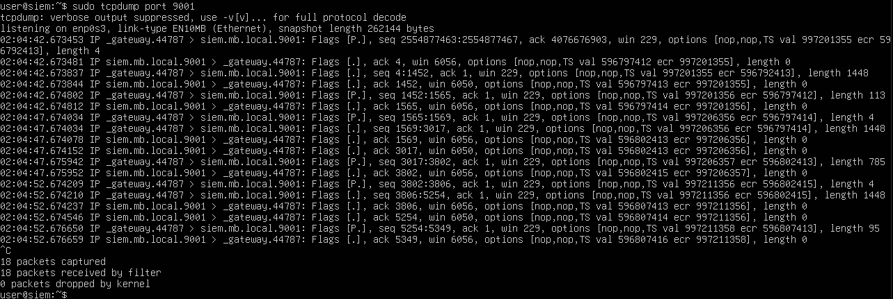

At the time of writing, all devices (SIEM, FIREWALL, WIN11 CLIENT AND SERVER) could all ping each other without issue.

Screenshot showing logs of an attempted SYNFLOOD attack.
